Project Log

1 Things we have learned about data set:

Our dataset is the voice data and gender label. We have done some simple plots on the variable as followed.

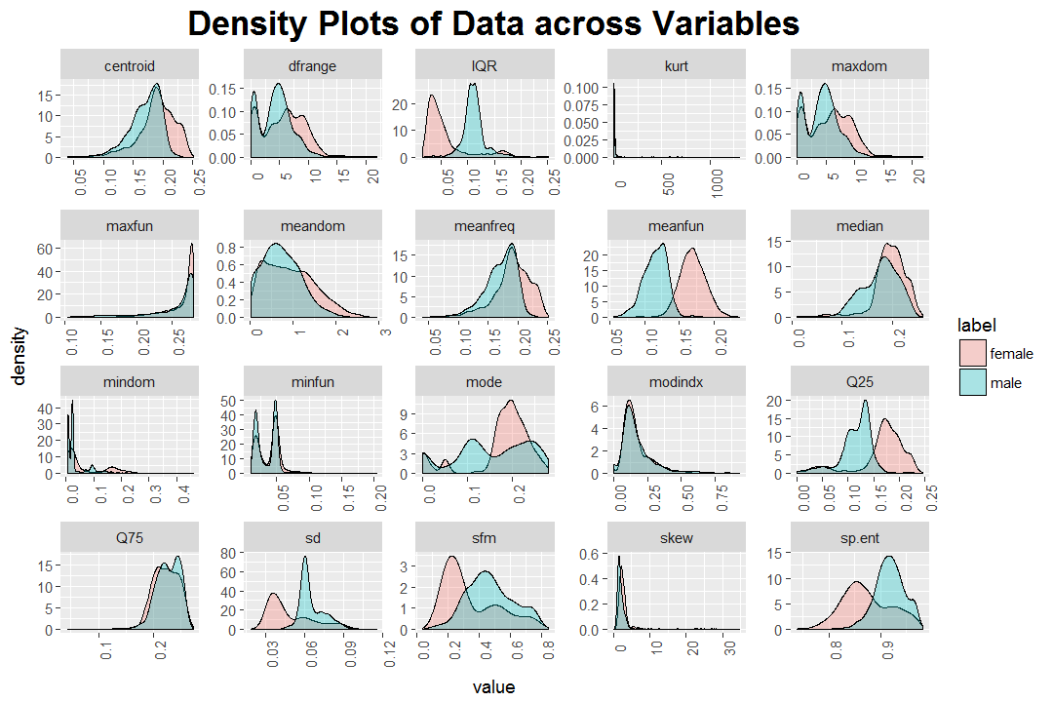

We have also fitted some model with the parameter to predict the true label, gender of the voice data. So far the best we get is 97% accuracy.

2 Difficulties

Since there are so many parameters to use, one big difficulty is that we have no idea which one are dominant.

3 Something that will guide our work:

We think the lab notes we have studied so far is a good material.